**Individual report**

This form is submitted by every member of your group and used to assess the level of teamwork in your group and the contribution of individuals. It may also form the basis of discussions which affect the grades received by individual group members.

|  |  |  |  |
| --- | --- | --- | --- |
| Student Number | First Name | Last Name | Group No |
| 1723936 | Buddha | Lama | 1 |

I was a group leader of my group. So, my first duty was to prepare a work plan and make sure we stick to that work plan in order to complete our task in time. I have to do work division. While dividing work, I was not biased because I had to make sure that everyone will contribute their work in every part of our work. I had conducted meeting minimum twice a week to make sure the work progress and we are following our work plan.

**My Contribution**

According to our work division, I have to prepare sequence diagram. Then, I had to design the register and login as well as I have to implement both pages in NetBeans IDE. I had needed to work on functionality of register and login. But, there was a problem while connecting the database so I look documents in oracle site and ask help to Kshitij Bajagain. He helped me to connect the oracle database and helped me to execute query according to our database schema. I had to prepare non-functional pages like Why Us and Accommodation. I had to prepare pdfs of help and brochure which is assist user. During testing, we are discussing about the system. There may be some unauthorized users which may have account. So, we decided to give privilege to admin to delete the unauthorized users. Similarly, some time students may forget the password. So, they can contact the admin and make their password changed. I have also prepare a weekly report which has been attached in group report. The work division table is shown below:

**Work Division**

|  |  |  |  |
| --- | --- | --- | --- |
| **S. N.** | **Name** | **GUI &**  **Implementation** | **Diagrams &**  **Documentation** |
| 1 | Kshitij Bajagain | Student Dashboard , Events & Booking, My/All Booking , Account Details ,Clubs , Admin Dashboard design and their functionalities | ER Diagram, Class Diagram, Design and implementation, work division. |
| 2 | Lokendra Dangi | Add Events , Alter Events , Update Events, Delete Events design and their functionalities | UseCase Diagram, Class Diagram, Introduction of report, Testing part. |
| 3 | Buddha Lama | Register Page , Login Page , Why Us , Help, Brochure, Accommodation , User Information(admin) design and their functionalities | Sequence Diagram, Class Diagram. Project plan. |
| 4 | Prabin Chapagain | Browser Functionality , Campuses (Luton, Bedford, Aylesbury, Milton Keynes, Putter ridge , Patan College) ,Education Loan | Activity Diagram, Class Diagram, agile and primary research. |
| 5 | Prajwol Thapa | Splash Screen , Kiosk Main Home Courses(Undergraduate , graduate , Foundation and International Students) , Invoice Generation | Sequence Diagram, Class Diagram, aims and objectives and critical analysis. |

**Note: The screenshots of my part of work is attached in appendix**

**Conclusion**

It was a wonderful opportunity to work with my team. As I was a group leader, so I had learned about how I can manage my team for completion of work in time. I had also learned how I can make effective plans and manage communication with group member. It was a wonderful opportunity to learn from my group members to improve my weakness. Similarly, I had also got opportunity to share my ideas with my teammates and receive ideas to make our work more user friendly. Moreover, it was wonderful opportunity to me develop my leadership skills which is very handy in future. This kind of project has helped to work on personal development and mind boosting capabilities.

|  |  |  |  |
| --- | --- | --- | --- |
| Student Number | First Name | Last Name | Contribution  (N,S,I) |
| 1723333 | Kshitij | Bajagain | S |
| 1720849 | Lokindra | Dangi | S |
| 1721484 | Prabin | Chapagain | S |
| 1727479 | Prajwol | Thapa | S |

**S** -Significant (The group member’s work was integral to the overall submission)

**N** -No Contribution (The group member took no part in the project submission)

**I** -Insignificant (The group member’s work made little difference to the overall submission)

**Appendix**

The screenshot of register page is shown below:

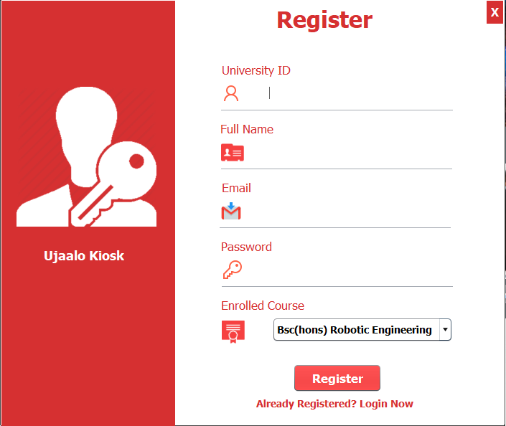

The screenshot of Login

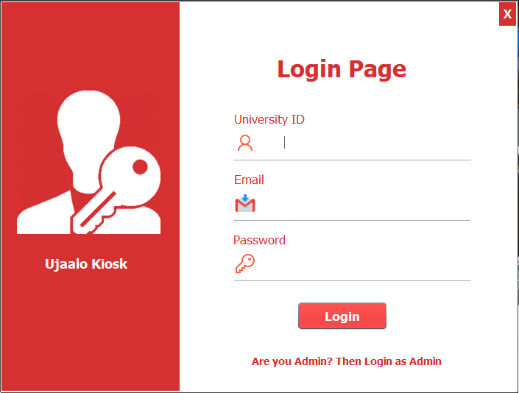

The Screen shot of alteration of User Information

